**Assignment 5- Tableau Story**

Course: 6380.003

Name: Anamika Das

Net ID: axd240045

1.

2. The primary focus is on:

1. **Customers**: Grocery shoppers and their habits.
2. **Business Stakeholders**: Managers and marketers implementing strategies.
3. **Data Analysts**: Crafting data-driven solutions.

3. The key decision-maker in the audience is likely the **Chief Marketing Officer (CMO)** or **Head of Marketing**. This role oversees promotional strategies, customer engagement initiatives, and program approvals.

4. Question 4 was missing in the Word document.

5. The scope of the audience is **narrow**. It targets specific groups, such as grocery customers, business stakeholders, and data analysts, focusing on those directly involved in grocery shopping patterns and promotional strategies. This ensures tailored and impactful communication.

6. Audience cares about:

1. **Customer Satisfaction**: Ensuring convenience and a seamless shopping experience.
2. **Data-Driven Insights**: Practical recommendations and measurable outcomes from analysis.
3. **Profitability**: Strategies that boost sales and customer engagement while reducing gaps between orders.

7. Audience needs to:

1. **Approve the Promotional Program**: Decision-makers, like the CMO, need to endorse the proposed strategy.
2. **Implement Changes**: Stakeholders should act on insights to reduce the time between grocery orders, such as launching targeted campaigns or incentives.
3. **Engage Customers**: Use data-driven techniques to connect with shoppers and encourage more frequent purchases.

8. The stakes are:

1. **Customer Engagement**: Encouraging customers to shop more frequently.
2. **Business Growth**: Boosting sales and reducing time between orders.
3. **Strategic Success**: Ensuring the promotional program achieves its goals and justifies the investment

9. The big idea is:

Encouraging customers to shop more frequently by implementing a data-driven promotional program, reducing the time between orders, and boosting customer satisfaction and sales.

10.

11.

**Saturday**, **Sunday**

12.

13. Order hours 10 – 16 are the busiest hours. The top 11 busiest hours are 10, 11, 15, 14, 13, 12, 16, 9, 17, 18, 8.

14.

15.

16. **Banana** is sold most during the busiest hour.

17.

18. Customers will most likely order again on the **last day** of the **first week** of the month.

19.

20. The top 3 best-selling products are:

1. Banana 2. Bag of organic Banana 3. Organic strawberries

21.

22.

23. **Raw Veggie Wrappers** is the most reordered product. Probability of reordering: Serenity pad, chocolate love bar.

24.

25. Number of 5 most often order.

26.

27. 1. Fresh fruits 2. Fresh vegetables 3. Packaged vegetables fruits

28.

29. Produce dairy egg.

30.

31.

32.

33.

34. A sequenced and numbered storyline of titles using Freytag’s Pyramid using the phases:

1. **Busiest Hours** - *Beginning*: Sets the stage by presenting peak activity hours, introducing the audience to the context.

2. **Busiest Days of the Week** - *Rising Action*: Expands on the context by identifying trends over the week and peak activity days.

3. **Days Since Prior Order** - *Rising Action*: Adds depth by showcasing customer purchasing intervals, hinting at opportunities for optimization.

4. **Number of Items Purchased** - *Climax*: Delivers the critical point of understanding customer buying habits and basket sizes.

5. **Best Selling Products** - *Falling Action*: Begins to wrap up by focusing on the most successful products and their performance.

6. **Treemap of Aisles and Products** - *Falling Action*: Visualizes product placement and connections to sales, reinforcing earlier findings.

7. **Top Products per Group** - *Resolution*: Ends with a summary of standout products, tying all insights together for actionable conclusions.

35. The type of rhetoric best suited for shaping a story about a new promotional program aimed at reducing the time between grocery orders is **Persuasive Rhetoric**, combining(Pathos, Logos, and Ethos)

1. **Pathos**: Emotional appeal, emphasizing customer convenience and benefits.

2. **Logos**: Logical appeal, using data to show the program’s effectiveness.

3. **Ethos**: Credibility, highlighting organizational trust and expertise.

36.

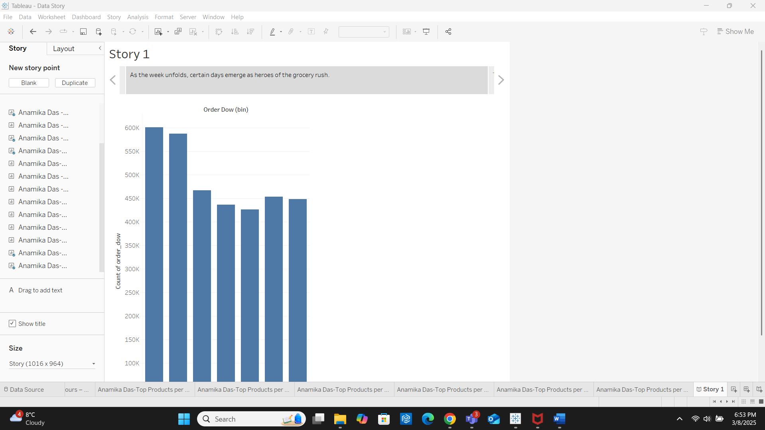

37.

38.

39.

40.

